**TASK#1 :**

<https://leetcode.com/problems/concatenation-of-array/submissions/1371848050>

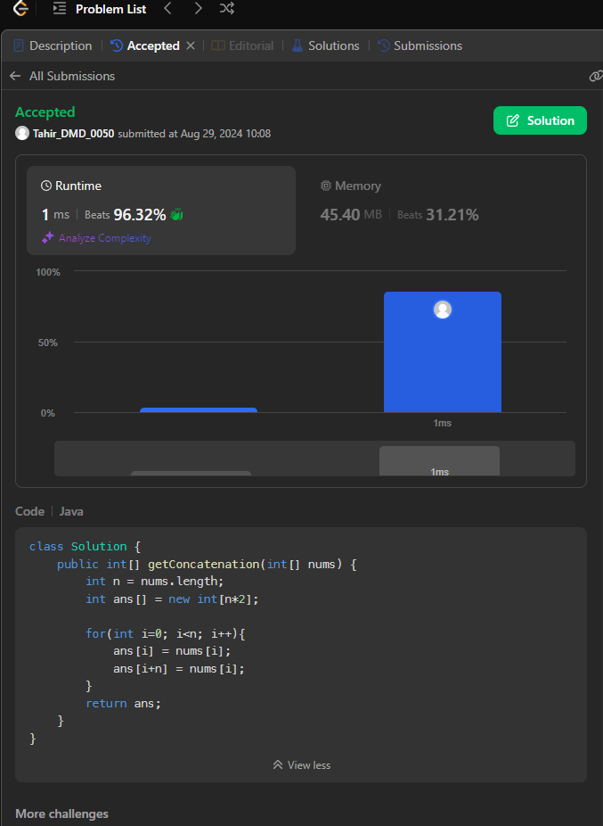

**TASK#2**

<https://leetcode.com/problems/find-words-containing-character/submissions/1371873864>

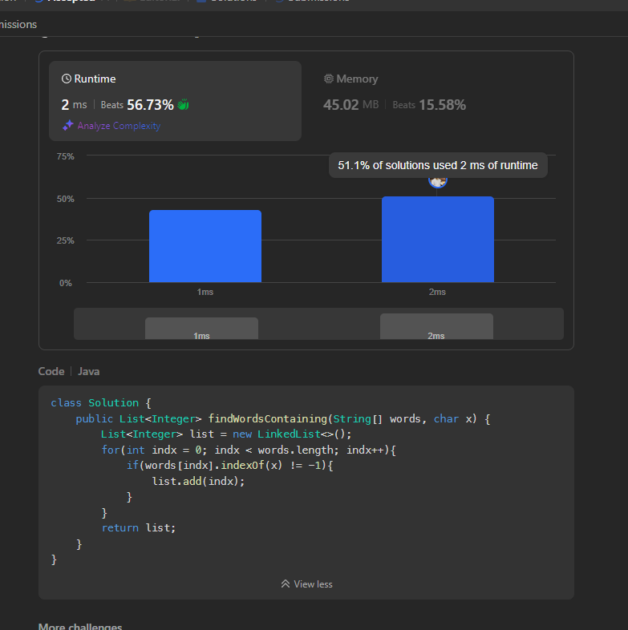

**TASK#3 :**

<https://leetcode.com/problems/maximum-number-of-words-found-in-sentences/submissions/1371912414>

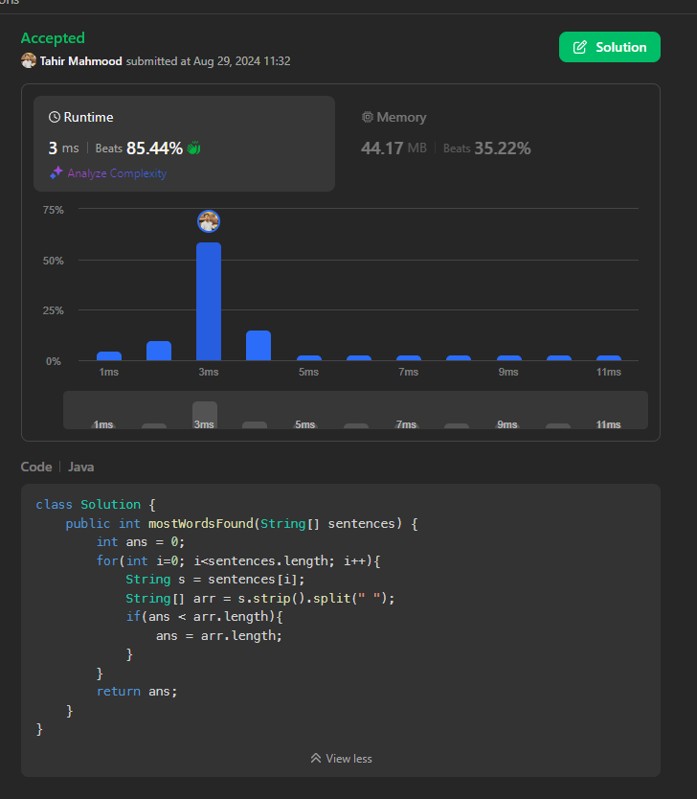

**Task #04**

<https://leetcode.com/problems/count-number-of-pairs-with-absolute-difference-k/submissions/1371937343>

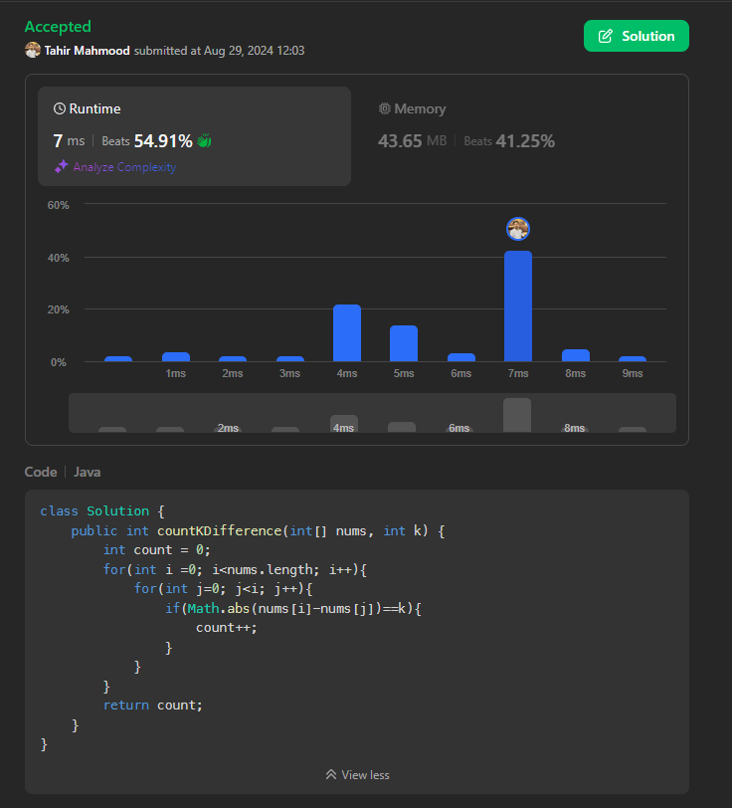

**Task #05**

<https://leetcode.com/problems/find-common-elements-between-two-arrays/submissions/1373887514>

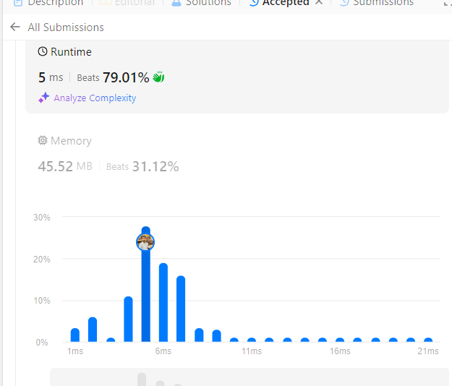

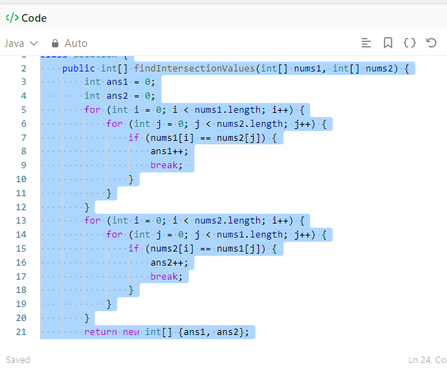

**TASK 6.**

<https://leetcode.com/problems/count-primes/submissions/1373897470>

